Discrete variable | Continuous variable
PMF: $f\left(a\right)=P(X=a)$ | PDF: $f(x)$  $$P\left(a<X<b\right)=\int_{a}^{b}{f\left(x\right)dx}$$
CDF: $F\left(a\right)=P\left(X≤a\right)=\sum_{x_{0}}^{a}{f(x_{i})}$ | CDF: $F\left(a\right)=P\left(X≤a\right)=\int_{-∞}^{a}{f\left(x\right)dx}$
Mean: $μ=\sum_{i=1}^{n}{x_{i}f(x_{i})}$ | Mean $μ=\int_{-∞}^{∞}{xf\left(x\right)dx}$
Variance: $σ^{2}=\sum_{i=1}^{n}{x_{i}^{2}f(x_{i})}-μ^{2}$ | Variance  $σ^{2}=\int_{-∞}^{∞}{x^{2}f\left(x\right)dx}-μ^{2}$  $$=\int_{-∞}^{∞}{{(x-μ)}^{2}f\left(x\right)dx}$$
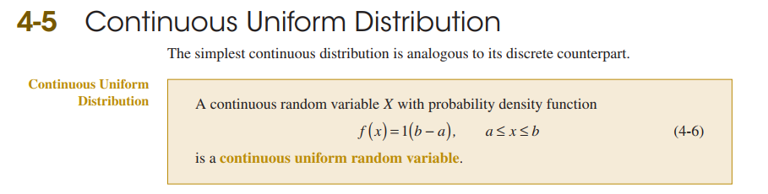

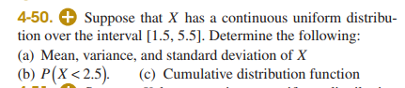

4.6. Continuous Normal Distribution
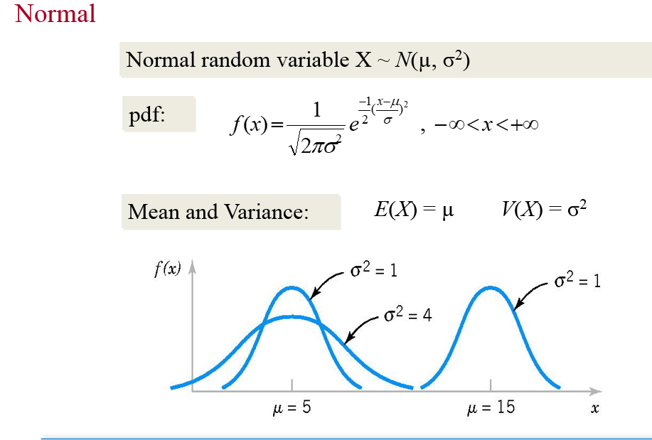

Standardized normal distribution
$$Z=\frac{X-μ}{σ}$$

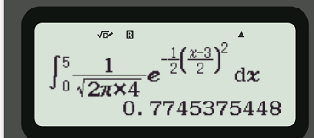

Ex: Let X ~ N(34, 144). Find P(X < 43) and P(24 < X < 37).
$$X: μ=34; σ^{2}=144→σ=12$$
$$f\left(x\right)=\frac{1}{\sqrt{2πσ^{2}}}e^{-\frac{1}{2}{\left(\frac{x-μ}{σ}\right)}^{2}}$$

$$P(24 < X < 37)$$

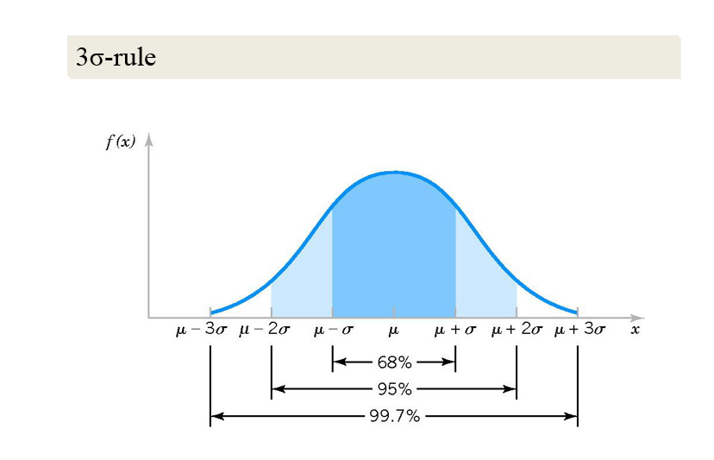
$$F\left(a\right)=P\left(X<a\right)=\int_{-∞}^{a}{f\left(x\right)dx}$$

Example: $X∼N\left(μ; σ^{2}\right)=N(2, 9)$
$$μ=2;σ=3$$
$$P\left(X<5\right)=0.841345$$
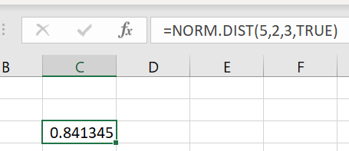

Excel chi tinh duoc Cumulative Distribution $P(X≤a)$

Ex:
$$X∼N\left(μ; σ^{2}\right)=N(2, 9)$$
$$μ=2;σ=3$$

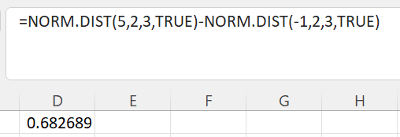

$$P\left(-1<X<5\right)=P\left(X<5\right)-P\left(X<-1\right)=0.6827$$

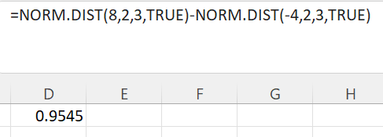
$$P\left(-4<X<8\right)=P\left(X<8\right)-P\left(X<-4\right)=0.9545$$

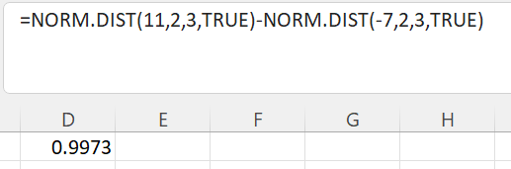
$$P\left(-7<X<11\right)=P\left(X<11\right)-P\left(X<-7\right)=0.9973$$

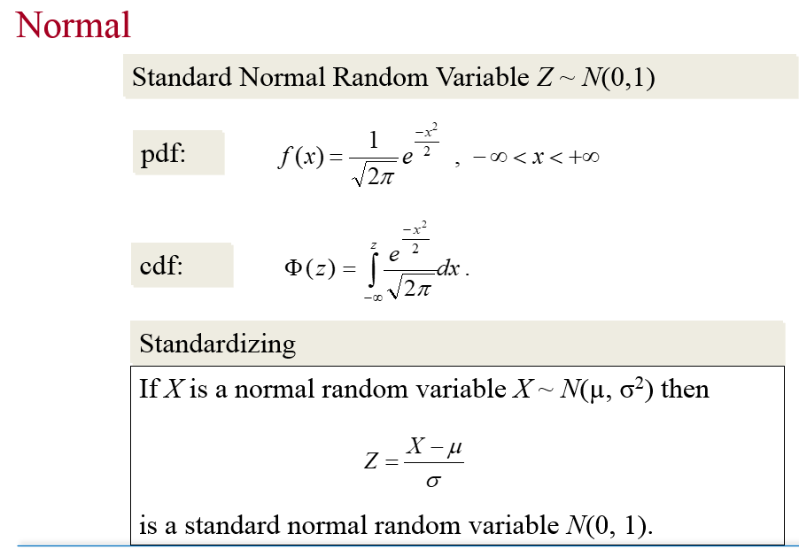

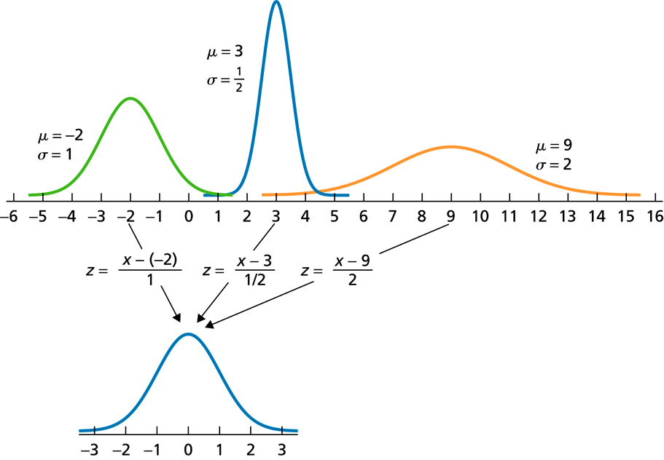

$$Z=\frac{X-μ}{σ}$$
Ex: $X∼N\left(μ; σ^{2}\right)=N(2, 9)$
$$μ=2;σ=3$$
$$Z=\frac{X-2}{3}$$
$$Z∼N(0,1)$$

$$P\left(X<5\right)=P\left(\frac{X-2}{3}<\frac{5-2}{3}\right)=P(Z<1)$$

Example: Let $Z∼N\left(0,1\right)$
$$P\left(Z<3\right)?$$
Mode 7: Distribution  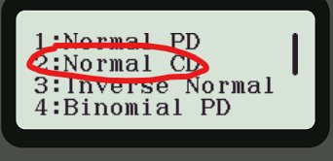 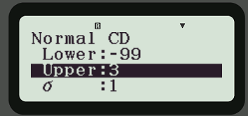 
KQ: 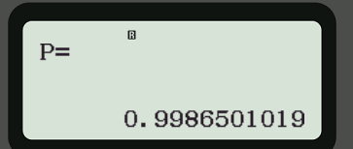

Example: $X∼N\left(3, 16\right)$
$$μ=3, σ=4$$
$$P(X<5)$$


Casio 570 Vnplus
Mode $↓$
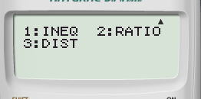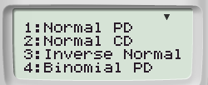
Lam tuong tu casio 580
Ex: "Assume X is normally distributed with a mean of 5 and a standard deviation of 4. Determine the following:
a) P(3 ≤ X ≤ 7)
b) P(3 < X < 7)
c) P(X > 5)
d) P(X ≤ 4)”
$$μ=5, σ=4$$
$$X∼N\left({5,4}^{2}\right)$$

Ex: An electrical firm manufactures light bulbs that have a life, before burn-out, that is normally distributed with mean equal to 800 hours and a standard deviation of 40 hours. Find the probability that a bulb burns between 778 and 834 hours.
$$μ=800, σ=40$$
$$X∼N({800,40}^{2})$$
$$P\left(778<X<843\right)$$


Ex: An airline knows from experience that the distribution of the number of suitcases that get lost each week on a certain route is approximately normal
with $μ= 15.5$ and $σ= 3.6$. What is the probability that during a given week the airline will lose less than 20 suitcases?
Let P(Z< -1.25) =0.1056, P(Z< < -0.37) =0.3944, P(Z< -0.24)=0.4040 and P(Z< 1.25) =0.8944.

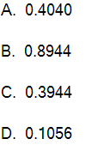

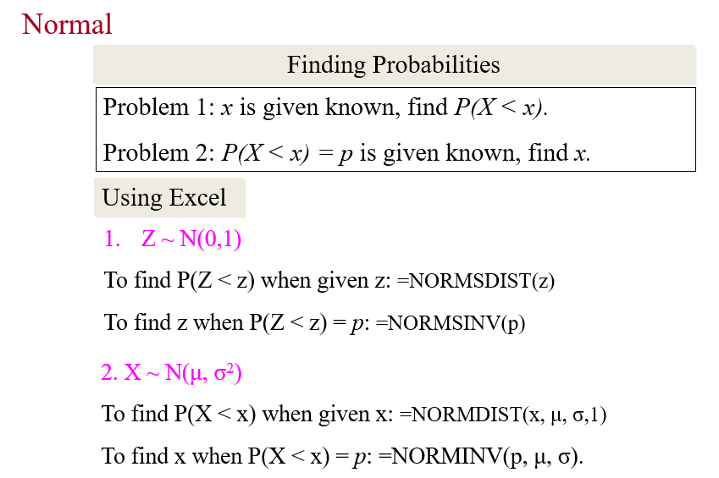

Trong bài toán 2, ta dùng lệnh NORM.INV (đối với Norm distr) và NORM.S.INV (đối với standard norm distr) trong excel để tìm x.
EX: Let $Z \sim N(0,1).$ Find the value of a to P(Z > a) = 0.95
$$P\left(Z>a\right)=0.95$$
$$→P\left(Z<a\right)=1-P\left(Z>a\right)=1-0.95=0.05$$
$$P\left(Z<a\right)=0.05$$
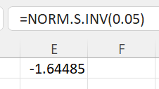 $→z= -1.64485$
Khi không dùng được excel thì đề sẽ cho biết thông tin về $P\left(Z<a\right).$
$P\left(Z<-1.645\right)=0.05$; $P\left(Z<-1,96\right)=0.025$
Casio:

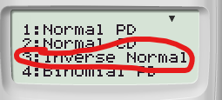
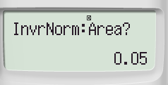
Casio 580 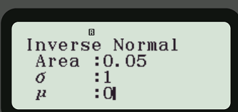
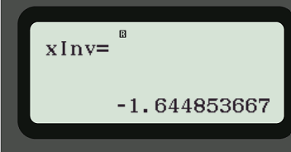

Ex: If we know that the length of time it takes a college student to find a parking spot in the library parking lot follows a normal distribution with a mean of 3.5 minutes and a standard deviation of 1 minute, find the point in the distribution in which 75.8% of the college students exceed when trying to find a parking spot in the library parking lot.
Let P(Z< -0.7) = 0.242, P(Z < -0.1) = 0.460 and P(Z < 0.7) = 0.758.

A.2.8 minutes B. 3.2 minutes
C. 3.4 minutes D. 4.2 minutes
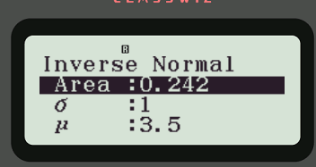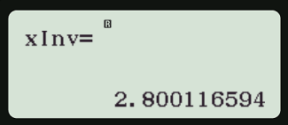

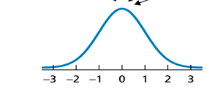

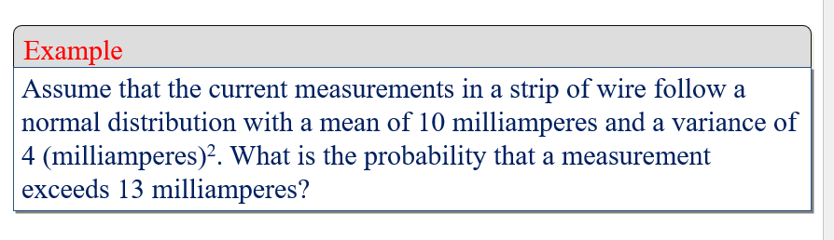
$$X∼N\left(μ; σ^{2}\right)=N(10;4)$$
$$μ=10;σ=\sqrt{4}=2$$
$$P\left(X>13\right)=$$

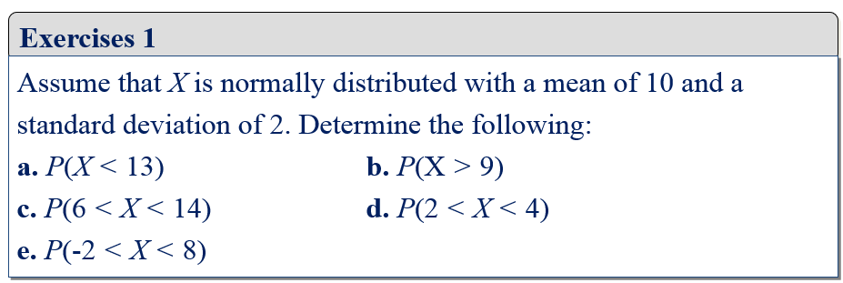

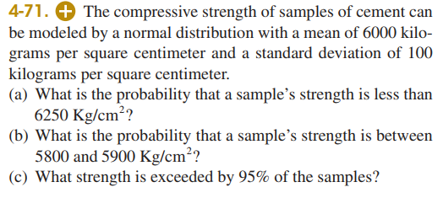
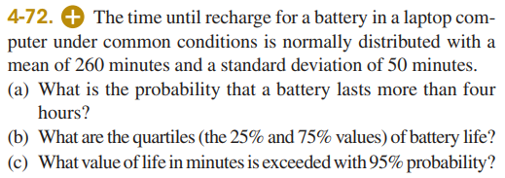

4.7. Normal approximation to the Binomial and Poisson.

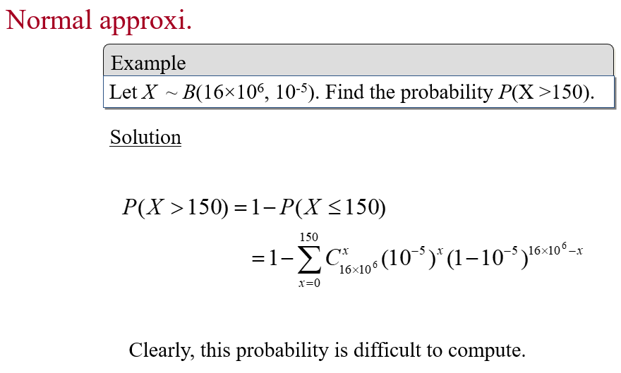
$$X∼B\left(n,p\right)$$
$$μ=np;σ=\sqrt{np(1-p)}$$
$$X≈Z=\frac{X-μ}{σ}=\frac{X-np}{\sqrt{np(1-p)}}$$
$$P\left(X>150\right)=P(X≥151)=P(X≥150.5)$$
$$X>150→X=151, 152…$$
$$X>150.5→X=151, 152,…$$
$$P\left(X≤30\right)=P(X≤30.5$$

Correction:
$$P\left(X≤a\right)=P\left(Z≤\frac{a+0.5-μ}{σ}\right)$$
$$P\left(X≥a\right)=P\left(Z≥\frac{a-0.5-μ}{σ}\right)$$

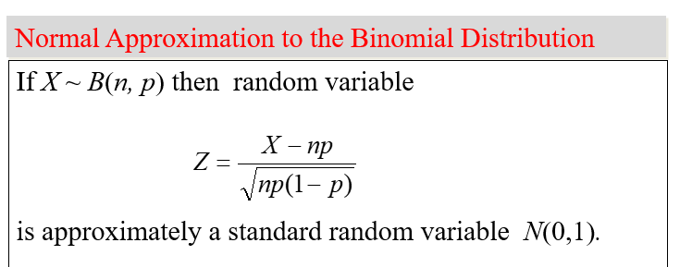
$$P\left(X≤a\right)=P\left(X≤a+0.5\right)$$
$$P\left(X≥a\right)=P(X≥a-0.5)$$
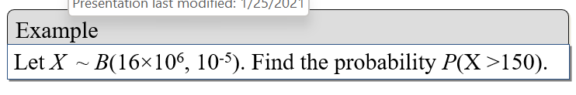
$$μ=np=16*{10}^{6}*{10}^{-5}=160$$
$$σ=\sqrt{np(1-p)}=\sqrt{16*{10}^{6}*{10}^{-5}\left(1-{10}^{-5}\right)}=12.65$$
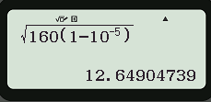

$$P\left(X>150\right)=P\left(X≥151\right)=P(X≥150.5)$$
$$=P\left(Z≥\frac{150.5-np}{\sqrt{np\left(1-p\right)}}\right)=P\left(Z≥\frac{150.5-160}{12.65}\right)$$

